Name: ______________________________________________________
Chapter 9 Study Guide

1. The United States

2. A barrier of troops or ships to keep people and supplies from moving in and out of an area

3. Setting free people who are enslaved

4. The rebuilding and healing of the country

5. The government formed by the states that seceded from the Union

6. Why did the North agree to the Missouri Compromise?

7. What do the following have in common – poll tax, literacy test, grandfather clause?

8. What was the Confederacy’s strategy when the Civil War began?

9. Why did the Republicans in Congress want to impeach Andrew Johnson?

10. What new war technology was introduced during the Civil War?

11. What did the Confederate states have to do to be allowed back into the United States?

12. What was the Union’s goal when the Battle of Bull Run began?

13. Which military leader used the strategy “total war?”

14. What new technology changed the way people at home understood the Civil War?

15. Why was it surprising that Robert E. Lee led the Confederate army?

16. Who was Sojourner Truth?

17. Why did the Union want to capture Vicksburg?

18. How did African American men help the Union during the Civil War?

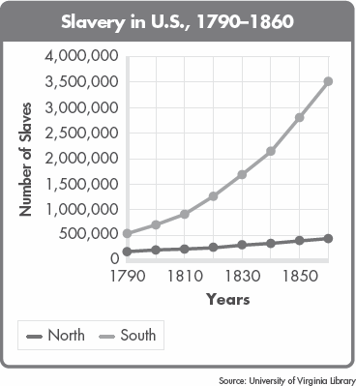

19. What happened to the growth of slavery between 1790 and 1860?

20. About how many enslaved people in total were in the United States in 1860?

21. In 1858, Abraham Lincoln said, “A house divided against itself cannot stand.” What did Lincoln mean?

22. Which side – Union or Confederacy – do you think had the greatest chance of winning the Civil War when the war began? Support your answer with two reasons.

23. Describe two ways that women participated in the Civil War.

