Name: _______________________________________________________
Chapter 8 Study Guide

1. The idea that the U.S. had a right to add territory until it reached Pacific Ocean

2. Making many goods at the same time by using interchangeable parts

3. A line of wagons traveling west as a group

4. A human-made waterway

5. Unfair treatment

6. What did Samuel F.B. Morse invent?

7. Which two immigrant groups worked hard as miners in California, even though they faced discrimination?

8. Why was the invention of the mechanical reaper important?

9. Why were entrepreneurs able to earn profits in businesses related to the Gold Rush?

10. How did Samuel Slater have a role in technological advances?

11. How do you “pan” for gold?

12. Which transportation improvements are described below:
-waterway which made it faster to move farm goods
-allowed boats to travel against the currents
-could be built anywhere, rather than having to follow rivers or canals

13. What are two main trails to the West that settlers and traders followed in the 1800’s?

14. List the sequence of events that led to statehood for Texas.

15. Who was Brigham Young, and why did he begin the Mormon Trail?

16. How did slavery influence the American settlement of Texas?

17. What groups did traders frequently trade with along the Old Spanish Trail?

18. What attracted settlers to the Oregon Country in the 1840’s?

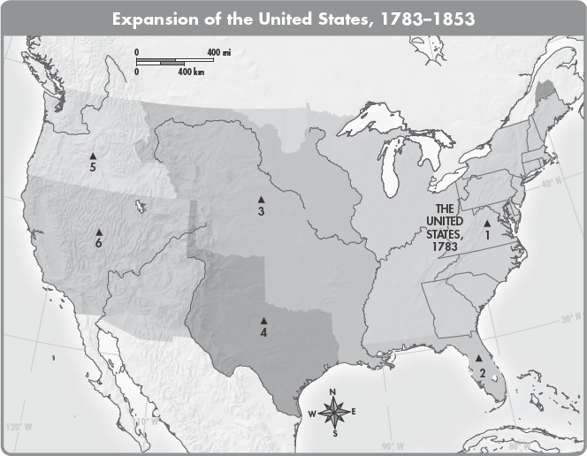

19. Which area of the map identifies Texas?

20. What area of the map identifies the territory that the U.S. received in the Treaty of Guadalupe Hidalgo?

21. The early 1800’s saw several major technological advances that improved transportation in the United States. Name two of those advances, and explain how they improved transportation.

22. Identify two obstacles to the expansion of the United States from the Atlantic Coast to the Pacific Coast.

23. Some settlers moved west because of attractive opportunities. Others moved west because of troubles they faced in the East. Give one example of each type of settler, and explain why they moved west.

24. Explain why the Gold Rush was a major factor in California becoming a state.

25. Discuss the role of the Chinese in the California Gold Rush.

