Name: __________________________________________________________
Chapter 7 Study Guide

1. A group of advisors to the president

2. Someone who settles a new place before others

3. The forced journey of Native American groups to Indian Territory

4. The goal of the movement that fought to end slavery

5. Pride in one’s nation

6. What did Washington call each person he chose to run a department within the Executive Branch?

7. What did some women do to improve society in the early 19th century?

8. Which two members of Washington’s Cabinet were the founders of political parties?

9. Which abolitionist was a former slave and also supported women’s rights?

10. How did the new capital of Washington D.C. symbolize the new nation?

11. What was the main message of the Monroe Doctrine?

12. How did the cotton gin make growing cotton profitable?

13. Why did James Monroe order Andrew Jackson into Florida?

14. What was the purpose of the Indian Removal Act of 1830?

15. How did the War of 1812 change the way Americans viewed their nation?

16. Why did people begin to move west of the Appalachian Mountains?

17. What event inspired Francis Scott Key to write the “Star Spangled Banner?”

18. Why was Jefferson able to make the Louisiana Purchase?

19. Why was it difficult for the United States to remain neutral in the war between Great Britain and France?

20. What was a major outcome of the Lewis and Clark Expedition?

21. Why did Washington’s Cabinet Secretaries Alexander Hamilton and Thomas Jefferson have so many disagreements?

22. Which Native American nation that lived in Florida fought the United States Army in order to try to keep their homeland? What was the outcome of their fight?

23. By the 1820’s, many states had granted the right to vote to all white men, not just those who owned property. What American president probably benefited from this change? Why?

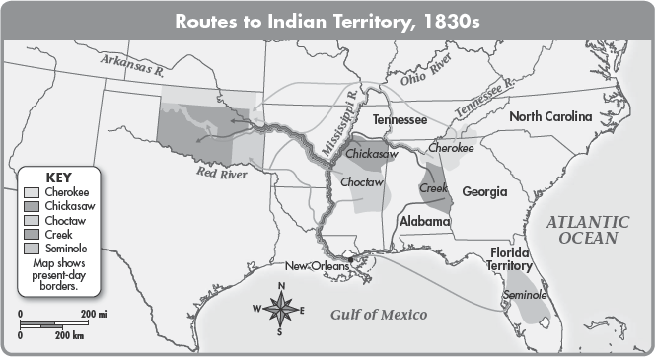

24. Where was the Indian Territory located on the map? Why did Congress create the Indian Territory?

