Name: _______________________________________________________
Chapter 6 Study Guide

1. A law

2. Ways that each branch of government limits the power of the other branches

3. An addition

4. Dividing the government so that each branch balances the powers of the others

5. Government in which citizens have power to make political decisions

6. What was a difference between the Articles of Confederation and the Constitution?

7. Which branch of the military patrols the coastline?

8. Why were war debts a problem for the new nation?

9. Social Security is a government program that is an example of what?

10. What caused Shays’ Rebellion?

11. At first, who were the only citizens who could vote?

12. What was the original purpose of the Constitutional Convention?

13. Rule of law, judicial review, and popular sovereignty are examples of what?

14. What did the Three-Fifths Compromise do?

15. What is an example of civic responsibility?

16. Why did states with large populations favor the Virginia Plan?

17. What can only a national government do?

18. Why did some states hesitate to ratify the Constitution?

19. “Those gentlemen, who will be elected senators, will fix themselves in the federal town, and become citizens of that town more than of your state.”
The speaker is revealing that he or she is what?
A. supporter of a strong central government
B. supporter of George Washington as the first president
C. supporter of the Declaration of Independence
D. supporter of the Articles of Confederation

20. “The powers not delegated to the United States by the Constitution, nor prohibited by it to the States, are reserved to the States respectively, or to the people.”
This amendment was a victory for who?
A. those who wanted a strong central government
B. those who supported James Madison’s view
C. Anti-Federalists
D. Nationalists

21. What were two weaknesses of the Articles of Confederation?

22. Identify two groups of Americans who did not have the right to vote when the Constitution was written, but who have that right now. How has expanding the right to vote helped fulfill the promises of the Constitution?

23. What is judicial review? How is it an example of checks and balances?

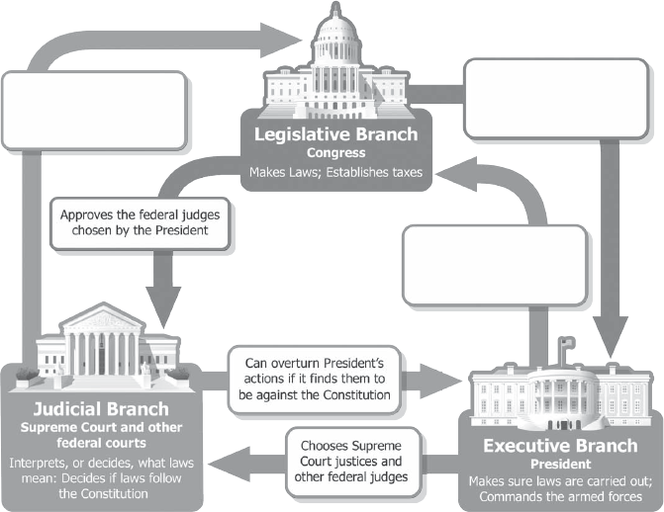

24. Fill in the blanks on this graphic.

25. How does the system of checks and balances strengthen democracy in the United States? Support your answer with one example from the graphic.

